**Answer Analysis Capability**

1. From the first login to the web ADMTC went smoothly.

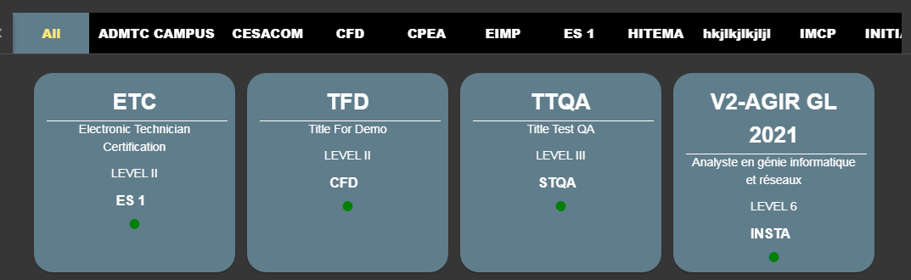2. Then the first page appears in terms of the interface starting to get messy and confusing the user because there are so many short words and has many options on the first menu. In my opinion, if improvements are made, the first page will be made very simple for each choice or category.

3. Performance from one page to another is quite long.

4. It is better if there are differences in data per year or use the year category from the database for schools, students and companies.

Example :

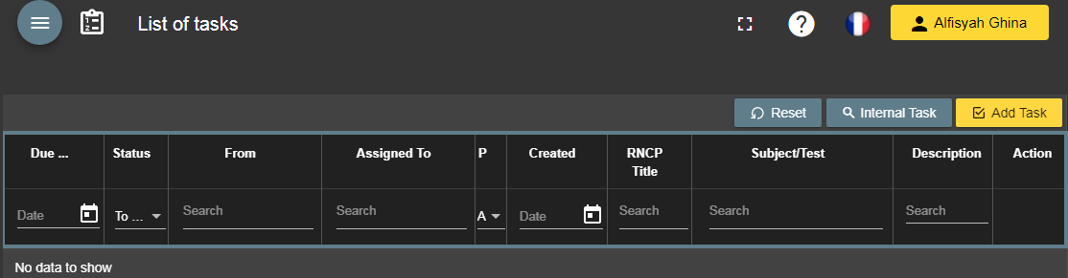5. Task menu if not needed should be removed.

6. Mailbox and Message menu should be selected one to be used to make it more simple.

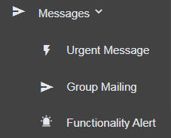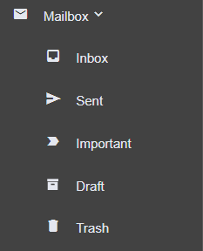

7. Too many menu options for a platform.

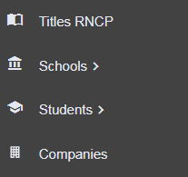 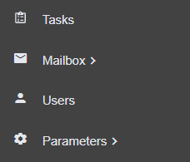 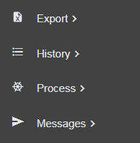

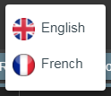8. We recommend that you add the translation for Indonesian, not just English and French.

9. Column displays are not the same as other columns.

10. Takes a long time to export existing files.

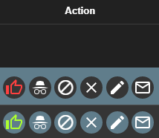11. Too many actions on each row of data.

12. Alerts appear very often so they need improvement.

13. Each parameter has no clear purpose.



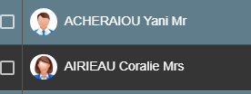14. Nickname Mr or Mrs should be put in front of the name.

15. Many symbols aren’t clear. Should be given a description of the color of the intended symbol. Example: Green is..... Red is.......